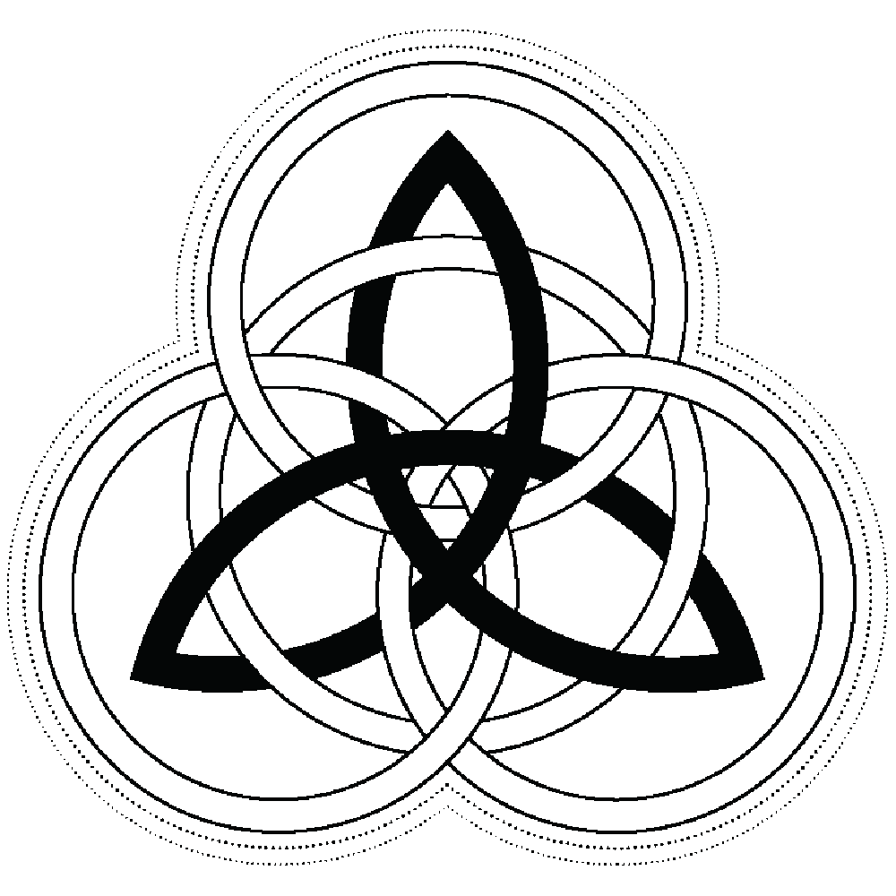
ARIZONA IRISH LASS APPLICATION FORM
(Please Submit Digitally)

Deadline April 15, 2021
Selection is Sunday, April 18, 2021 at the Irish Cultural Center

Name (full): _______________________________________________________________________

Address (full): ____________________________________________________________________

Name known by: ______________________ Birth date: _________________ Age: _______

Parent’s required: E-mail _________________________________________________________

Parent’s required: Cell ______________________________ First name ___________

Lass’s optional: E-mail ____________________________________ Cell ___________________
All entrants must:
a) Be at least 13 and not more than 17 years of age by February 13, 2021 for the Arizona Irish Lass Selection.
b) Be of Irish origin by virtue of one of her ancestors having been born in Ireland, or born in Ireland herself.
c) Be available for MANDATORY events including:
- Arizona Colleen & Rose Selection, May 15, 2021
- Irish Cultural Center Gala, Fall 2021
d) Be available for other community events as they become known.

Parent(s) Name(s): _______________________________________________________________

I, ____________________________________________ [name of parent/legal guardian], do hereby give my consent

for my daughter, ______________________________________ [name of applicant], to participate in the Arizona Irish Lass competition, I do hereby attest that she is of Irish descent, and I give permission for the use of photographs and recordings of said events to be used in marketing and promoting the Arizona Colleen Selection and its related programs.

Signature of Parent _____________________________________________________ Date ______________________

Please submit a completed application, along with a clear photo, and a $40 nonrefundable fee, and send to chair@azcolleen.org (payment can be made online or by cash or check).

Once submitted, NEXT steps are to complete and send the 2021 Questionnaire and the 2021 Short Essay by the deadline. Questions? Email Ciara Archer, chair@azcolleen.org or Mallory Melton, mallorygmelton@gmail.com

