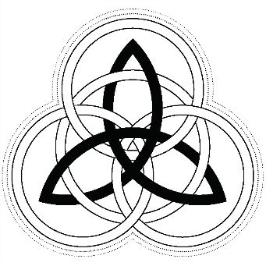
Little Miss Shamrock 2020
QUESTIONNAIRE

Ages 6 through 12 years old; must have some Irish ancestry; reside in Arizona during her reign; able to attend scheduled activities for the Arizona Colleen Programs.

ENTRY DEADLINE IS January 12, 2020
Please print or type responses (in the child’s words; a parent may help with handwriting or typing. Be complete. Attach additional pages if needed.

Full Name ____________________________________ Grade in School ___________________

Name known by _________________________ Birthdate _________________ Age ________

Favorite Movie __________________________________ Favorite Game ________________

Favorite Movie __________________________________ Favorite Game ________________

Favorite Book __________________________________ Author ________________________

Favorite Book __________________________________ Author ________________________

Hobbies/Sports/Like to Do _______________________________________________________

_______________________________________________________________________________

_______________________________________________________________________________

_______________________________________________________________________________

_______________________________________________________________________________

When I Grow Up, I Want to Be and Why ___________________________________________

_______________________________________________________________________________

_______________________________________________________________________________

_______________________________________________________________________________
Irish Background/Traditions _____________________________________________________

_______________________________________________________________________________

_______________________________________________________________________________

I want to be Little Miss Shamrock because _________________________________________

_______________________________________________________________________________

_______________________________________________________________________________

_______________________________________________________________________________

Something unique about me to share ______________________________________________

_______________________________________________________________________________

_______________________________________________________________________________

_______________________________________________________________________________

Awards/Honors/Recognition _____________________________________________________

_______________________________________________________________________________

_______________________________________________________________________________

_______________________________________________________________________________

_______________________________________________________________________________

Parents’ Names _________________________________________________________________

Brothers & Sisters (names and ages) _______________________________________________

_______________________________________________________________________________

Contestant’s signature___________________________________________________________

Parent’s signature_______________________________________________________________

Please email this completed questionnaire & application to info@azcolleen.org

